**Final Year Software Project**

**Cab 9**

**Project Team**

**Hadi Bin Masood (09-0965)**

**Waleed Bin Khalid (11-0011)**

**Muhammad Raza (11-0012)**

**Supervised BY**

**Mr. Naveed Iqbal**

**Department of Computer Sciences**

**National University of Computer and Emerging Sciences**

**Islamabad, Pakistan 2013**



Table of Contents

Supervisor Approval 5

Intellectual Property Right Declaration 6

Anti-Plagiarism Declaration 7

Chapter 1. Iterations Plan 8

1.1 Iteration 1 Plan 8

1.2 Iteration 2 plan 8

1.3 Iteration 3 Plan 8

Chapter 2. Researcher’s Submission 9

Chapter 3. Project Vision 11

3.1 Introduction 11

3.2 Positioning 11

3.2.1 Business Opportunity: 11

3.3 Problem Statement 11

3.4 Stakeholder Descriptions 12

3.4.1 Stakeholder Summary 12

3.4.2 Key High Level Goals and Problems of Stakeholders 13

Chapter 4. Design 14

4.1 High Level Use Cases 14

4.2 Expanded Use Cases 17

4.2.1 Use Case # 1 17

18

4.2.2 Use Case # 2 19

4.2.3 Use Case # 3 21

22

4.2.4 Use Case # 4 23

4.2.5 Use Case # 5 25

4.2.6 Use Case # 6 27

4.2.7 Use Case # 7 29

4.2.8 Use Case # 8 31

4.2.9 Use Case # 9 33

4.3 Use Case Diagram 35

35

4.4 Domain Model 36

4.4.1 List of Concepts Using Noun Phrasing of Expanded Use Cases: 36

4.4.2 Relationships List Using Verb Phrasing 37

4.4.3 Conceptual Category List 38

4.4.4 Common Associations List 39

4.4.5 Attributes List 40

4.4.6 Domain Model Diagram 41

4.5 System Sequence Diagrams 42

4.5.1 Use Case: Add New Cab 42

4.5.2 Use Case: Allot Nearest Cab 42

4.5.3 Use Case: Book a Cab 43

4.5.4 Use Case: Cancel Booking 43

4.5.5 Use Case: Confirm Order 44

4.5.6 Use Case: Register User 44

4.5.7 Use Case: View Dashboard 45

4.5.8 Use Case: Alert for Roadblocks 45

4.6 Operation Contracts 46

4.6.1 Use Case: Add New Cab 46

4.6.2 Use Case: Allot Nearest Cab 47

4.6.3 Use Case: Book a Cab 48

4.6.4 Use Case: Cancel Booking 49

4.6.5 Use Case: Confirm Order 50

4.6.6 Use Case: Register User 51

4.6.7 Use Case: View Dashboard 52

4.6.8 Use Case: Alert for Roadblocks 53

4.7 Sequence Diagrams 54

4.7.1 Operation Contract: Add New Cab 54

4.7.2 Operation Contract: Cab Allotment Response 54

4.7.3 Operation Contract: Cancel Booking Request 55

4.7.4 Operation Contract: Display Dashboard 55

4.7.5 Operation Contract: Find Current Location 56

4.7.6 Operation Contract: Initialize 56

4.7.7 Operation Contract: Register User 57

4.7.8 Operation Contract: Set Destination 58

4.7.9 Operation Contract: Set Type of Cab 59

4.7.10 Operation Contract: Add Roadblock 59

4.8 Initial Class Diagram 60

4.9 Package Diagram 61

4.10 Deployment Diagram 62

Chapter 5. Database 63

5.1 Entity Relationship Model (ERD) 63

5.2 ER Model to Tables 64

5.3 Relational Model (Normalized) 66

Chapter 6: USER MANUAL 67

Chapter 7. References 81

# Supervisor Approval

This document provides the final report of FYP-1 of the project “Cab 9”, Group No. 40.

**Supervisor**

Name: Mr. Naveed Iqbal

Signature: _________________ Date: _________________

# Intellectual Property Right Declaration

This is to declare that the work under the title: “Cab 9” is carried out in partial fulfillment of the requirements of: BS (CS) Final Year Project is the sole property of the National University of Computer and Emerging Sciences, and is protected under the intellectual property right laws and conventions. It can only be considered/ used for purposes like extension for further enhancement, product development, adoption for commercial/organizational usage, etc. with the permission of the University.

This above statement applies to all students and faculty:

**Student 1**

Name: Waleed Bin Khalid

Signature: _________________

**Student 2**

Name: Muhammad Raza

Signature: _________________

**Student 3**

Name: Hadi Bin Masood

Signature: _________________

**Supervisor**

Name: Mr. Naveed Iqbal

Signature: _________________ Date: _________________

# Anti-Plagiarism Declaration

This to declare that the above publication produced under the title: **“Cab 9”** is the sole contribution of the author(s) and no part hereof has been reproduced on as it is basis (cut and paste) which can be considered as Plagiarism. All referenced parts have been used to argue the idea and have been cited properly. I/We will be responsible and liable for any consequence if isolation of this declaration is determined.

**Student 1**

Name: Waleed Bin Khalid

Signature: _________________

**Student 2**

Name: Muhammad Raza

Signature: _________________

**Student 3**

Name: Hadi Bin Masood

Signature: _________________

# Chapter 1. Iterations Plan

## 1.1 Iteration 1 Plan

Iteration 1 implements 2 use case that are following:

1. Book a cab
2. Register user

## 1.2 Iteration 2 plan

Iteration 2 implements 2 use case that are following:

1. Authenticate the user
2. Add new cab

## 1.3 Iteration 3 Plan

Iteration 3 implements and improves the following use cases the following use cases:

1. Allot nearest cab
2. View Dashboard

# Chapter 2. Researcher’s Submission

According to the research carried out by the FYP group, similar work has been done and deployed already in the world but careful analysis yields some deficiencies that this Final Year Project aims to rectify. The overview of the features present in the existing systems is as follows:

|  |  |  |  |  |  |  |  |
| --- | --- | --- | --- | --- | --- | --- | --- |
| Features | Applications | | | | | | |
|  | **Taxi Pixi Cab Booking [1] [2]** | **Dial A Cab [3]** | **Go Taxi Cloud [4]** | **Easy Taxi [5]** | **mTAXI [6]** | **Unicablink / Sunlight Taxi [7]** | **Cab 9** |
| Order Acknowledgement by the Driver | **🗸** | **🗴** | **🗸** | **🗴** | **🗴** | **🗴** | **🗸** |
| Booking Cancellation Option | **🗸** | **🗸** | **🗸** | **🗴** | **🗴** | **🗴** | **🗸** |
| Acquiring Customer Location Through GPS | **🗴** | **🗸** | **🗸** | **🗸** | **🗴** | **🗴** | **🗸** |
| Estimated Time of cab Arrival | **🗴** | **🗸** | **🗴** | **🗴** | **🗴** | **🗴** | **🗸** |
| Navigation and Routing for Cab Driver | **🗴** | **🗴** | **🗴** | **🗴** | **🗴** | **🗴** | **🗸** |
| Approximate Fare Calculation for Customer | **🗴** | **🗴** | **🗴** | **🗴** | **🗴** | **🗴** | **🗸** |
| Roadblock Alerts for Cab Driver | **🗴** | **🗴** | **🗴** | **🗴** | **🗴** | **🗴** | **🗸** |
| Cab location monitoring and live business statistics for better management | **🗴** | **🗴** | **🗴** | **🗴** | **🗴** | **🗴** | **🗸** |

# Chapter 3. Project Vision

## 3.1 Introduction

A system that will enable best utilization of cab company resources through localization bringing convenience and time saving for customer and efficiency to financial and resource management of Cab Company. Our system aims at relieving the customer from problems like finding the cab, excessive fares, delays due to traffic rush etc. It also allows the company management to monitor the financial statistics live and also the monitor business of the day. It also makes sure the most optimum use of resources creating value for customer and increasing profit margins for company.

## 3.2 Positioning

### 3.2.1 Business Opportunity:

There are loads of Cab companies working throughout the whole world so it’s a business opportunity to provide them with solutions that can help them as well as their customers to interact in a better way with the company through a mobile application that provides them with the facility of booking for their cab from their smart phone. It will not only help and facilitates the customer but will also facilitate the owner and manager of the company to better manage and monitor their company vehicles and services area wise. This application will add value to company in not only customer perspective in ease of booking but also in good business analytics displayed to the owner for better decision making. So in these ways our system holds a big opportunity in the cab business.

## 3.3 Problem Statement

There are a lot of cab companies out there. But there is no well-developed and well maintained centralized system that would avoid the customer the need of roaming around to find a cab, negotiating with the cab driver for fare or waiting a long time for cab (in case of phone call booking for a cab). The management of a cab company is also a costly and hectic process if done manually. Our project will address this problem by allowing the customer to order a cab with absolute ease being aware of the estimated fare and estimated time of arrival of cab (ETA) beforehand. Our project will also target at improving the service quality and making the management of Cab Company efficient by trying to achieve resource efficiency and quick delivery of cabs to customers. Our project will also provide an option choose from different classes of cabs and provide emergency or special care services.

## 3.4 Stakeholder Descriptions

### 3.4.1 Stakeholder Summary

Following are the stake holders of our system:

1. Customer
2. Company Owner
3. Cab driver
4. Company Manager

|  |  |  |
| --- | --- | --- |
| S.no. | Stake Holder | Interests |
| 1 | Customer | Customer needs to know the ETA (Estimated Time of Arrival) of his/her assignment cab and in some cases the tracking of the concerned cab. Moreover customer is interested in knowing the fare beforehand. |
| 2 | Company Owner | Company owner has interests in smooth and efficient running of his business. He is interested in monitoring the whole business processing for example movement of cabs , list of idle cabs, fare collected by different cabs, drivers data etc. |
| 3 | Cab Driver | Cab driver needs to know the route he will be using to reach his destination and fare he is supposed to collect from the customer, and the next destination. |
| 4 | Company Manager | Manager wants cab monitoring, monitoring of business statistics for analysis and deployment of cabs in a particular area. |

### 3.4.2 Key High Level Goals and Problems of Stakeholders

|  |  |  |  |
| --- | --- | --- | --- |
| High Level Goals | Priority | Problems & Concerns | Solutions |
| Providing customer with ease to order cab | High | Earlier, the maximum facility that was given was by a phone call. Normally customer has to roam around to find a cab. | Customer will be given to order cab from a mobile app and customer location will be acquired through GPS. |
| Providing customer with ETA and Estimated Fare | Medium | No earlier system provides the customer with ETA and Estimated Fare beforehand. | Customer will be notified of ETA of cab on the basis of distance between allotted cab and customer. And the fare to destination will be calculated on the basis of distance of selected route. |
| Business Management | High | Business owner wants efficient and inexpensive management of his company making sure efficient utilization of resources. | Live dashboard will display business statistics and enable live monitoring of cabs. Nearest cab in customer vicinity based allocation for efficient resource usage. |
| Navigation and Routing | High | Navigation on the shortest and most optimum route for the cab driver so as to achieve fuel efficiency and time saving. | Algorithms for optimum route calculation will be developed which will consider avoiding busy routes at peak hours of the day as well. |
| Roadblock alerts | Low | Inform manager in case of any roadblocks. | Manager will be notified of the roadblocks and alternate route decision will be taken accordingly. |

# Chapter 4. Design

## 4.1 High Level Use Cases

1. **Use Case:** Authenticate the user

**Actors:** Cab Driver, Customer, Owner, Manager (Administrator)

**Type:** Primary

**Description**: All above mentioned actors will login to system after validating their unique username and password.

1. **Use Case:** Book a cab

**Actor:** Customer

**Type:** Primary

**Description:** Customer will enter request for cab booking. System will acquire customer location and forward the request to the manager.

1. **Use Case:** Allot nearest Cab

**Actors:** Customer

**Type:** Primary

**Description:** System according to the location of customer will allocate the nearest idle cab to the request automatically.

1. **Use Case:** Confirm Order

**Actor:** Cab Driver

**Type:** Primary

**Description:** After the allocation order has been sent by the administrator to the cab driver, the cab driver will confirm the request. A notification will be sent to the administrator of the confirmation. ETA and estimated fare will be notified to the customer and optimum route will be calculated for the driver and he will be provided with the navigation.

1. **Use Case:** View Dashboard

**Actors:**  Owner, Manager

**Type:** Primary

**Description:** Manager will log in to the system and select view dashboard option and system will generate the dashboard on which sales of the day information along with location and status of cabs on the map will be displayed.

1. **Use Case:** Register User

**Actors:** Customer

**Type:** Primary

**Description:** Customer will sign up for the system, fill in required information and the request will be transferred to the administrator for account creation. Administrator (Manager/Owner) will be able to review and approve/reject the registration request. And if manager approves the registration, new user account will be created.

1. **Use Case:** Add New Cab

**Actors:** Manager

**Type:** Primary

**Description:** Manager will add a new cab into the system by entering all the information regarding the cab like registration number, model, make, color, chassis number and mileage. The driver dedicated for the cab will also be added into the system.

1. **Use Case:** Cancel booking

**Actors:** Customer

**Type:** Secondary

**Description:** Customer will be able to cancel his booking within a specific time period after which he will have to pay for the distance driver will cover from his location to the customer’s location.

1. **Use Case:** Alert for Roadblock  
   **Actors:** Manager  
   **Type:** Secondary  
   **Description:** Manager will inform all the drivers about a roadblock which will be avoided during optimum route calculation.

## 

## 4.2 Expanded Use Cases

### 4.2.1 Use Case # 1

|  |  |
| --- | --- |
| Use Case Name: | Authenticate the user |
| Scope: | Cab 9 (System under development) |
| Level: | User Goal |
| Primary Actor: | User (Customer, Admin, Cab Driver, Owner) |
| Stakeholders and Interests: | Customer, Admin, Cab Driver, Owner   1. **User:** User wants to login to the system and use it. 2. **Admin and Owner:** Wants to ensure security and prevent any unauthorized usage. Wants to ensure restricted access. |
| Pre-Condition: | User must already be registered within the system. |
| Success Guarantee: | * User logged in successfully. * User session created. * User granted access according to the type of user. |
| Main Success Scenario: | 1. User starts the application. 2. User clicks Login button. 3. User enters Username and Password. 4. User Presses Sign in button. 5. User is logged in. 6. User session is created. |
| Extensions (Alternative Flows): | **4a. Login failed**   1. User entered invalid Username and Password    1. User enters the correct Username and Password and goes to step 4. 2. User is not registered    1. User will press the sign up button and get himself registered with the system first. |
| Frequency of Use: | This use case has high frequency of occurrence. |

## C:\Users\Raza\Desktop\Documentation\Activity Diagrams\Authenicating User.jpg

### 4.2.2 Use Case # 2

|  |  |
| --- | --- |
| Use Case Name: | Book a cab |
| Scope: | Cab 9 (System under development) |
| Level: | User Goal |
| Primary Actor: | Customer |
| Stakeholders and Interests: | Customer, Admin   1. **Customer:** Wants to book a cab for travelling. 2. **Admin:** Wants to know about a customer cab booking to carry out further process. |
| Pre-Condition: | Customer must already be registered within the system and logged in. |
| Success Guarantee: | * Customer location acquired successfully through GPS. * Cab booking request forwarded to admin along with customer’s preferences. |
| Main Success Scenario: | 1. User starts the application on his windows phone. 2. User logs in. 3. User clicks the Book a Cab button. 4. User location is acquired through GPS. 5. User enters the destination. 6. User selects the type of cab i.e. **Executive** or **Economy.** 7. The user request is forwarded to the administrator. |
| Extensions (Alternative Flows): | **\*a. User does not enter all the required preferences**   1. System does not move forward without all the preferences required for cab booking.   **4a. User location cannot be acquired through GPS**   1. User is asked to enter the location manually. |
| Frequency of Use: | This use case has high frequency of occurrence. |

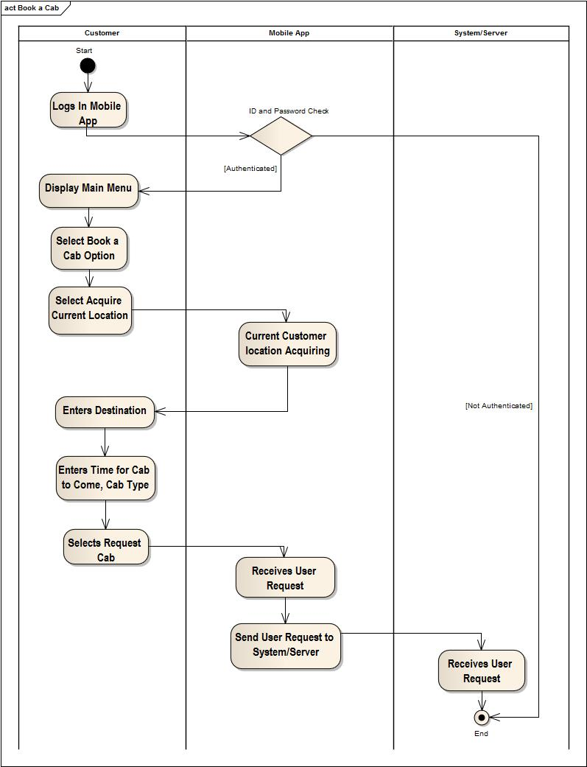

### 4.2.3 Use Case # 3

|  |  |
| --- | --- |
| Use Case Name: | Allot Nearest Cab |
| Scope: | Cab 9 (System under development) |
| Level: | User Goal |
| Primary Actor: | Administrator |
| Stakeholders and Interests: | Customer, Admin, Cab Driver   1. **Customer:** Wants to be allotted cab for his booking 2. **Admin:** Wants to allot the nearest cab to the customer. |
| Pre-Condition: | 1. User must already be registered within the system. 2. User must be logged in. 3. User must have made a request for cab booking. |
| Success Guarantee: | * The cabs in customer’s vicinity displayed to the administrator. * The administrator selects the nearest idle cab for allocation. * The order is forwarded to the cab driver for confirmation. |
| Main Success Scenario: | 1. New request for booking will appear in live dashboard in front of the administrator. 2. System will search for the nearest idle cab in customer’s vicinity. 3. The corresponding cab driver will be sent the order along with booking preferences. |
| Extensions (Alternative Flows): | **2a. There are no cabs in customer’s vicinity.**   1. System will find the nearest idle cab to the customer location and allocate that cab to the request. |
| Frequency of Use: | This use case has high frequency of occurrence. |

## C:\Users\Raza\Desktop\Documentation\Activity Diagrams\Allot Nearest Cab.jpg

### 4.2.4 Use Case # 4

|  |  |
| --- | --- |
| Use Case Name: | Confirm Order |
| Scope: | Cab 9 (System under development) |
| Level: | User Goal |
| Primary Actor: | Cab Driver |
| Stakeholders and Interests: | Customer, Admin, Cab Driver   1. **Customer:** Wants confirmation for his booking, notification of ETA and estimated fare. 2. **Admin:** Wants to confirm allocation of cab to a particular booking. |
| Pre-Condition: | 1. Cab driver must be signed in and authenticated in to the system. 2. Cab driver’s status should be live in the admin dashboard. 3. Cab status should be idle so that he can be given a new order. 4. A booking must have been made by the customer. |
| Success Guarantee: | * Acknowledgement sent to the administrator. * ETA and estimated fare notification send to the customer. * Optimum route calculated for the cab driver and navigation started. |
| Main Success Scenario: | 1. Cab driver will receive allocation order from the administrator. 2. Cab driver will acknowledge. 3. Acknowledgement will be sent to the administrator. 4. ETA and fare will be calculated and notified to the customer. 5. Optimum route will be calculated and navigation will be started for the cab driver. |
| Extensions (Alternative Flows): | None |
| Frequency of Use: | This use case has high frequency of occurrence. |

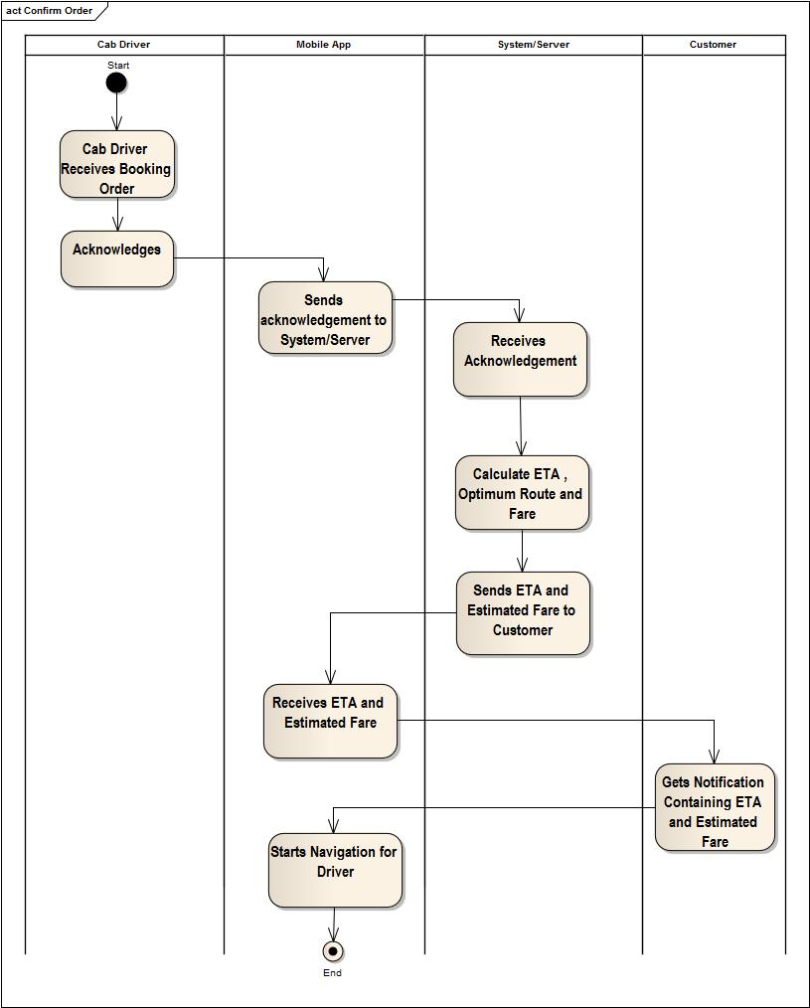

### 4.2.5 Use Case # 5

|  |  |
| --- | --- |
| Use Case Name: | View Dashboard |
| Scope: | Cab 9 (System under development) |
| Level: | User Goal |
| Primary Actor: | Administrator, Owner |
| Stakeholders and Interests: | Admin, Owner   1. **Admin and Owner:** Wants to monitor and manage the business efficiently along with monitoring of cabs. |
| Pre-Condition: | 1. Admin/Owner must already be signed in and authenticated in to the system. |
| Success Guarantee: | * The dashboard with live position of cabs on the map is displayed to the Admin/Owner. * Business statistics are displayed in a panel. * Requests for new bookings are appearing successfully. |
| Main Success Scenario: | 1. Admin/Owner clicks view dashboard option. 2. Live dashboard view is generated with live cab location monitoring on the map, business statistics and panel for new cab booking requests. |
| Extensions (Alternative Flows): | None |
| Frequency of Use: | This use case has high frequency of occurrence. |

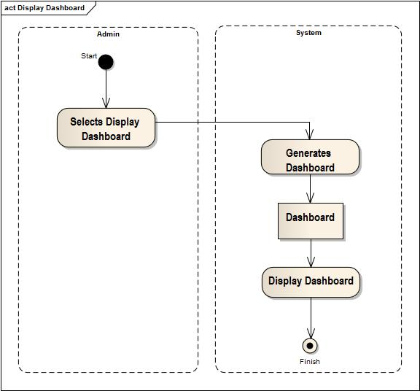

### 4.2.6 Use Case # 6

|  |  |
| --- | --- |
| Use Case Name: | Register User |
| Scope: | Cab 9 (System under development) |
| Level: | User Goal |
| Primary Actor: | Customer |
| Stakeholders and Interests: | Customer, Admin   1. **Customer:** Wants to be registered in to the system to be able to use the service. 2. **Admin:** Wants to review the new customer request. |
| Pre-Condition: | No Pre-Conditions |
| Success Guarantee: | * The new user request is forwarded to the Admin. |
| Main Success Scenario: | 1. User selects Sign Up on the application. 2. User is asked the required information in a form. 3. The request for new registration is forwarded to the Administrator. 4. Administrator after reviewing the registration request approves the registration. 5. New User Account is created. |
| Extensions (Alternative Flows): | **2a. User does not fill all the required information.**   1. User will not be allowed to submit the request until all the required information has been filled by the user.   **4. Administrator disapproves registration.**   1. User account is not created. |
| Frequency of Use: | This use case has medium frequency of occurrence. |

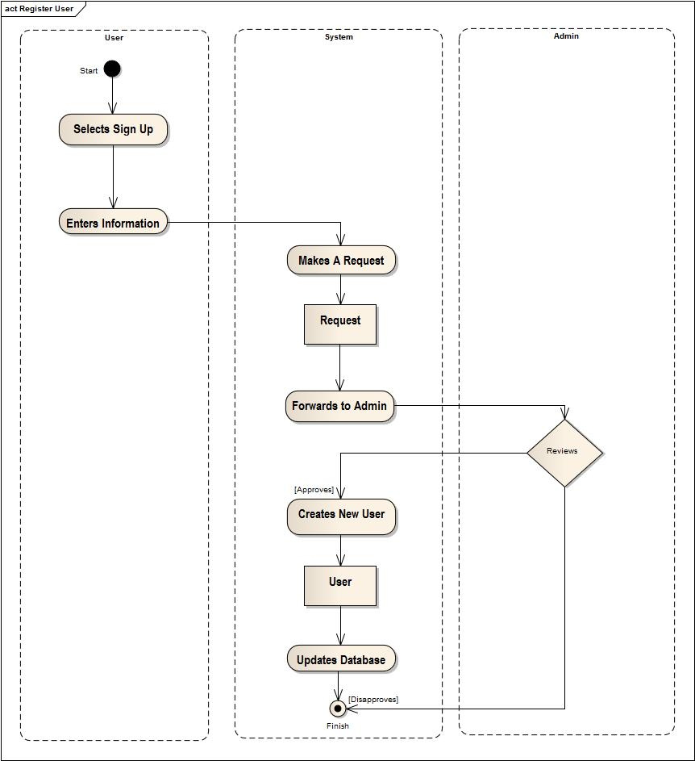

### 4.2.7 Use Case # 7

|  |  |
| --- | --- |
| Use Case Name: | Add New Cab |
| Scope: | Cab 9 (System under development) |
| Level: | User Goal |
| Primary Actor: | Administrator |
| Stakeholders and Interests: | Admin   1. **Admin:** Wants to add a new resource (cab) into the system. |
| Pre-Condition: | 1. Admin must already be logged in to the system and authenticated. |
| Success Guarantee: | * New cab along with the concerned information like registration number, model, make, color, chassis number, mileage and driver added to the system. |
| Main Success Scenario: | 1. Admin after logging in selects **Add New Cab** option. 2. Admin enters all the required information like registration number, model, make, color, chassis number, mileage and driver. 3. The new cab is added and system is updated. |
| Extensions (Alternative Flows): | **2a. Admin does not enter all the information required.**   1. Admin will be prompted about missing data before adding the cab to the system. |
| Frequency of Use: | This use case has medium frequency of occurrence. |

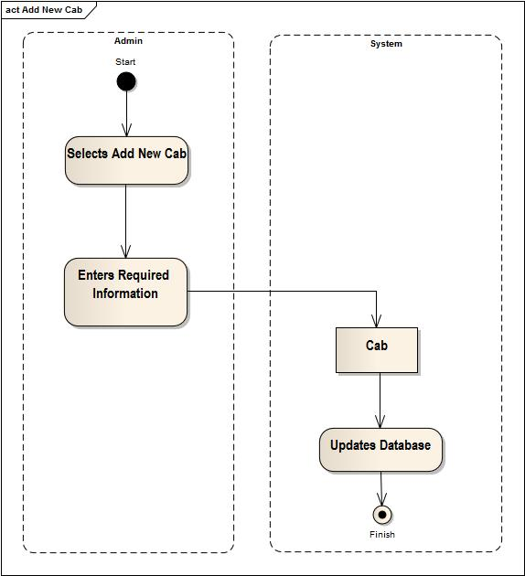

### 4.2.8 Use Case # 8

|  |  |
| --- | --- |
| Use Case Name: | Cancel Booking |
| Scope: | Cab 9 (System under development) |
| Level: | User Goal |
| Primary Actor: | System |
| Stakeholders and Interests: | Customer, Admin   1. **Customer:** Wants to cancel his booking for a cab. 2. **Admin:** Wants to know if user has cancelled booking timely. |
| Pre-Condition: | 1. Customer must already be registered within the system and logged in. 2. Customer must already has made a booking which needs to be cancelled. |
| Success Guarantee: | * Customer has been notified of the cancelled booking. * The allotted driver has been informed of the cancellation. * Admin dashboard has been updated. |
| Main Success Scenario: | 1. User selects the cancel booking option on mobile application. 2. The booking details are showed to him along with the cancel booking button. 3. User cancels the booking. 4. The cancellation notification is forwarded to the cab driver. 5. Admin dashboard is updated and booking removed from system. |
| Extensions (Alternative Flows): | **3a. User cancels the booking after specified duration for cancellation.**   1. The distance between cab driver and customer will be calculated and customer will be charged for the distance. 2. The driver will collect the fare and send request completion notification to the admin. 3. The admin dashboard will be updated. |
| Frequency of Use: | This use case has high frequency of occurrence. |

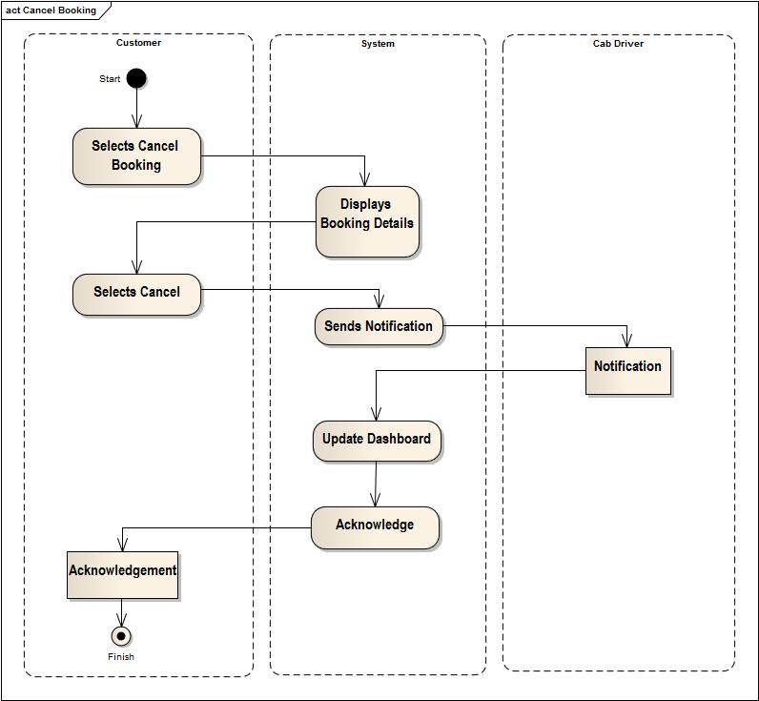

### 4.2.9 Use Case # 9

|  |  |
| --- | --- |
| Use Case Name: | Alert for Roadblocks |
| Scope: | Cab 9 (System under development) |
| Level: | User Goal |
| Primary Actor: | Administrator |
| Stakeholders and Interests: | Admin, Cab Driver   1. **Admin:** Wants to notify drivers about the roadblocks. 2. **Cab Driver:** Wants to be notified of the roadblock. |
| Pre-Condition: | 1. Admin must already be logged in to the system and authenticated. |
| Success Guarantee: | * Roadblock alert is sent to all the cab drivers. |
| Main Success Scenario: | 1. Admin after logging in to the system selects **Roadblock Alerts**. 2. Admin enters the location of the roadblock. 3. A notification is generated. 4. The notification is sent to the cab drivers. |
| Extensions (Alternative Flows): | None |
| Frequency of Use: | This use case has low frequency of occurrence. |

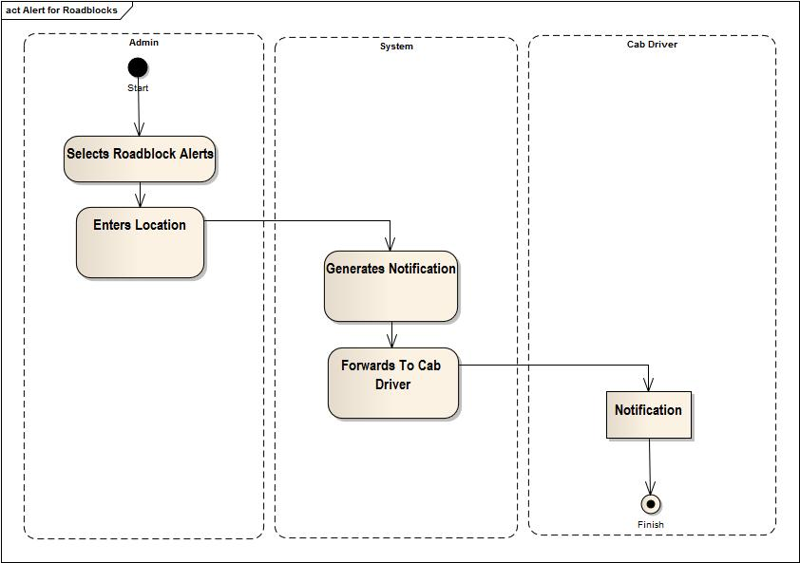

## 4.3 Use Case Diagram

# F:\Study\FYP\Documentation\Use Case Model.jpg

## 

## 4.4 Domain Model

### 4.4.1 List of Concepts Using Noun Phrasing of Expanded Use Cases:

1. Cab 9
2. Customer
3. Cab
4. Cab Driver
5. Owner
6. Security
7. Username
8. Password
9. Location
10. GPS
11. Booking Preferences
12. Booking Request
13. Destination
14. Type of Cab
15. Administrator
16. Dashboard
17. Order
18. Notification
19. ETA (Estimated Time of Arrival)
20. Estimated Fare
21. Optimum Route
22. Map
23. Cab Position
24. Business Statistics
25. Panel
26. Distance

### 4.4.2 Relationships List Using Verb Phrasing

|  |  |  |
| --- | --- | --- |
| Source Concept | Relationship | Target Concept |
| User | Enters | Username/Password |
| Customer | Books | Cab |
| GPS | Acquires | Location |
| Customer | Enters | Destination |
| Customer | Selects | Type of Cab |
| Cab 9 | Forwards | Booking Request |
| Cab 9 | Allots | Cab |
| Cab 9 | Forwards | Order |
| Cab 9 | Sends | Notification |
| Cab 9 | Calculates | Optimum Route |
| Admin/Owner | Views | Dashboard |
| Admin | Receives | Registration Request |
| Admin | Adds | Cab |
| Admin | Approves | Registration Request |
| Customer | Cancels | Booking |

### 4.4.3 Conceptual Category List

|  |  |
| --- | --- |
| Conceptual Class Category | Examples |
| Business Transaction | - |
| Transaction Line Items | - |
| Product or service related to a transaction or transaction line item | Cab Service |
| Where is the transaction recorded? | - |
| Roles of people or organizations related to the transaction; Actors in the use case | Cab Driver, Customer |
| Place of transaction; Place of service | Field, Customer location that is acquired through GPS |
| Noteworthy events; often with a time or place we need to remember | Cab Booking, Booking Cancellation, Notification, Order |
| Physical Objects | Cab, GPS Receiver, Windows Phone |
| Description of Things | User Description  Cab Description  Booking Details |
| Catalogs  Guideline: Descriptions are often in catalogs | User Profile  Cab Instance  Booking Instance |
| Containers of Things (Physical of Information) | - |
| Things in a Container | - |
| Other Collaborating Systems | - |
| Records of Finance, Work, Contracts, Legal Matters | - |
| Financial Instruments | - |
| Schedules, Manuals, Documents that are regularly referred to in order to perform work | - |

### 4.4.4 Common Associations List

|  |  |
| --- | --- |
| Category | Examples |
| A is a physical part of B | Cab Driver – Cab |
| A is a logical part of B | Cab Booking – Booking Preferences |
| A is physically contained in B | Cab Driver – Cab |
| A is logically contained in B | - |
| A is a description of B | Booking Preferences – Booking Request |
| A is a line item of a transaction or report B | - |
| A is a known / logged / recorded / reported / captured in B | - |
| A is member of B | - |
| A is an organization subunit of B | - |
| A communicates B | Customer – Admin – Cab Driver |
| A uses or manages B | Admin – Cab 9  Customer – Cab 9 |
| A is related to a transaction B | - |
| A is a transaction related to another transaction B | - |
| A is next to B | - |

### 4.4.5 Attributes List

|  |  |
| --- | --- |
| Concepts | Attributes |
| Cab | * Registration Number * Color * Chassis Number * Make * Model * Type |
| Booking Request | * Customer ID * Location * Destination * Time * Type * Special Care (Yes/No) |
| User | * Name * ID * Password * Age * Gender * Phone Number * Address * Type |
| Order (From Admin to Driver) | * Source * Destination * Time of Booking |

### 4.4.6 Domain Model Diagram

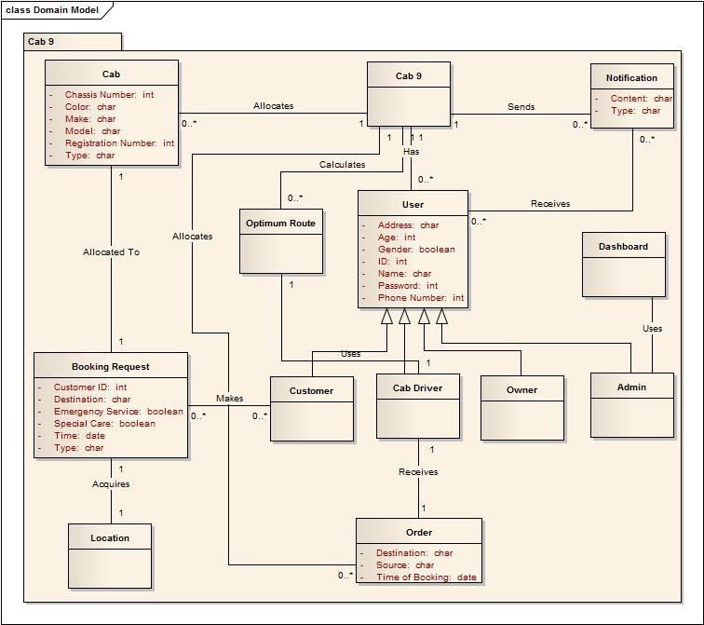

## 4.5 System Sequence Diagrams

### 4.5.1 Use Case: Add New Cab

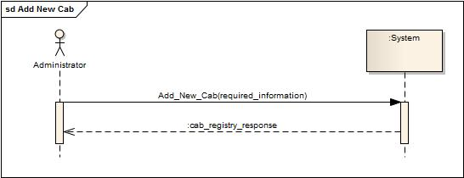

### 4.5.2 Use Case: Allot Nearest Cab

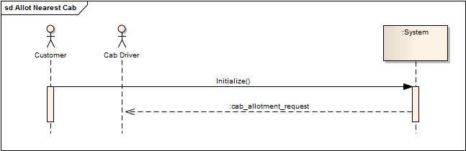

### 4.5.3 Use Case: Book a Cab

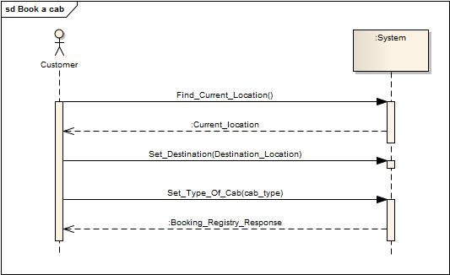

### 4.5.4 Use Case: Cancel Booking

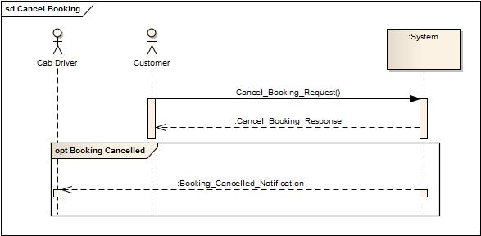

### 4.5.5 Use Case: Confirm Order

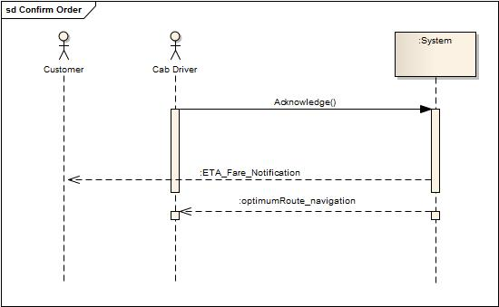

### 4.5.6 Use Case: Register User

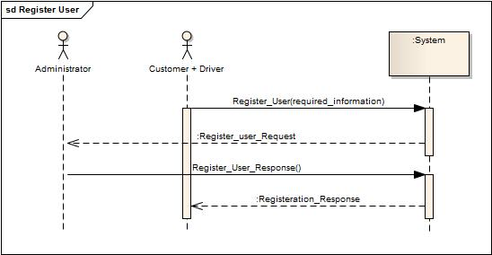

### 4.5.7 Use Case: View Dashboard

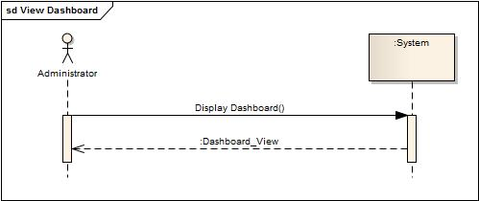

### 4.5.8 Use Case: Alert for Roadblocks

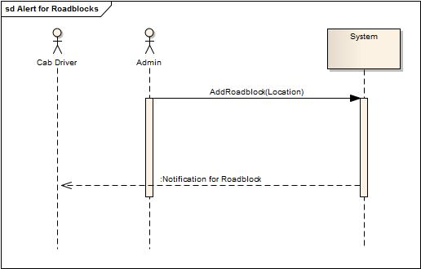

## 4.6 Operation Contracts

### 4.6.1 Use Case: Add New Cab



|  |  |
| --- | --- |
| Name | Add New Cab |
| Pre-Conditions | Admin must already be identified and authenticated. |
| Post-Conditions | 1. New instance of cab created (Instance Creation). 2. All the concerned information about cab is set (Attribute Modification). 3. Database Updated |

### 4.6.2 Use Case: Allot Nearest Cab



|  |  |
| --- | --- |
| Name | Initialize |
| Pre-Conditions | 1. Admin and customer must already be identified and authenticated. 2. An order must have been placed for cab by the customer. |
| ost-Cnditions | 1. System searches the nearest cab in customer’s vicinity. 2. An instance of order is created (Instance Creation). 3. Preferences of order are set according to the order booked by customer (Attribute Modification). 4. Order sent to the corresponding Cab Driver. |

### 4.6.3 Use Case: Book a Cab



|  |  |
| --- | --- |
| Name | Find Current Location |
| Pre-Conditions | 1. Customer must be identified and authenticated. 2. A new instance of booking must already have been created by the customer. 3. GPS receiver must be working. |
| Post-Conditions | 1. GPS receiver reads customer location. 2. Location is embedded into the booking preferences (Attribute Modification). 3. Customer location shown on map. |

|  |  |
| --- | --- |
| Name | Set Destination |
| Pre-Conditions | 1. Customer must be identified and authenticated. 2. A new instance of booking must already have been created by the customer. |
| Post-Conditions | 1. User enters destination. 2. GPS coordinates are calculated through reverse geo coding. 3. Customer location is shown on map. 4. Booking preferences updated (Attribute Modification). |

|  |  |
| --- | --- |
| Name | Set Type of Cab |
| Pre-Conditions | 1. Customer must be identified and authenticated. 2. A new instance of booking must already have been created by the customer. |
| Post-Conditions | 1. User selects type of cab. 2. Booking Preferences updated (Attribute Modification). 3. Booking request forwarded to admin. |

### 4.6.4 Use Case: Cancel Booking



|  |  |
| --- | --- |
| Name | Cancel Booking Request |
| Pre-Conditions | 1. Customer must be identified and authenticated. 2. A booking must already have been made by the customer. |
| Post-Conditions | 1. User selects to cancel the booking. 2. The booking instance is destroyed (Instance Deletion). 3. Customer is notified success. 4. Admin is notified about booking cancellation. 5. Live dashboard of admin updated. |

## 

### 4.6.5 Use Case: Confirm Order



|  |  |
| --- | --- |
| Name | Acknowledge |
| Pre-Conditions | 1. Cab driver must be identified and authenticated. 2. Cab driver must be allocated a customer request. |
| Pot-Conditions | 1. A new instance of notification created (Instance Creation). 2. Cab driver acknowledges. 3. Customer is notified of the ETA and optimum route is provided to the cab driver in form of navigation. 4. Admin is notified of the response. |

### 4.6.6 Use Case: Register User



|  |  |
| --- | --- |
| Name | Register user |
| Pre-Conditions | None |
| Post-Conditions | 1. User selects registration option (Instance Creation). 2. User enters required information (Attribute Modification). 3. Notification is sent to the admin (Instance Creation). 4. Admin approves the registration request. 5. Database is updated. |

### 4.6.7 Use Case: View Dashboard



|  |  |
| --- | --- |
| Name | Display Dashboard |
| Pre-Conditions | 1. Admin must be identified and authenticated. |
| Post-Conditions | 1. Admin selects view dashboard. 2. Dashboard instance created (Instance Creation). 3. Dashboard information updated (Attribute Modification). |

### 4.6.8 Use Case: Alert for Roadblocks



|  |  |
| --- | --- |
| Name | Add Roadblock |
| Pre-Conditions | 1. Admin must be identified and authenticated. |
| Post-Conditions | 1. Admin selects **Roadblock Alert**. 2. Admin enters location of the roadblock. 3. A notification is generated. 4. Notification is forwarded to the cab drivers. |

## 4.7 Sequence Diagrams

### 4.7.1 Operation Contract: Add New Cab

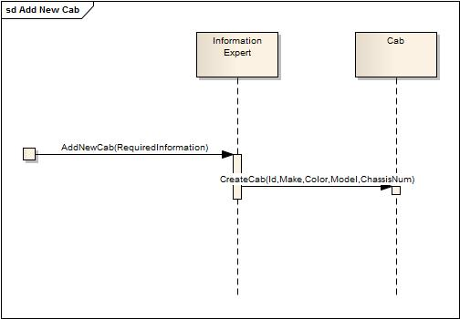

### 4.7.2 Operation Contract: Cab Allotment Response

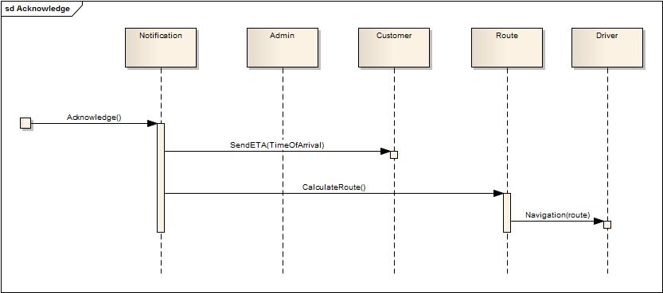

### 4.7.3 Operation Contract: Cancel Booking Request

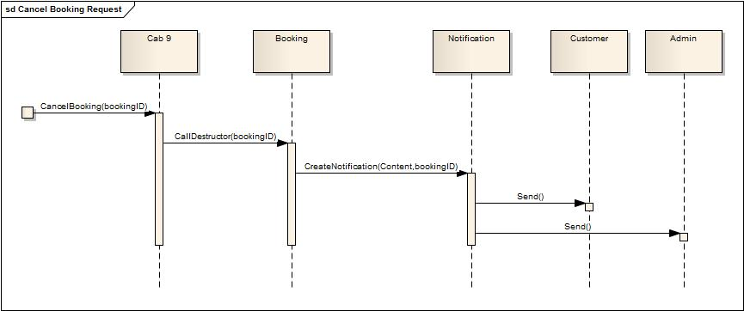

### 4.7.4 Operation Contract: Display Dashboard

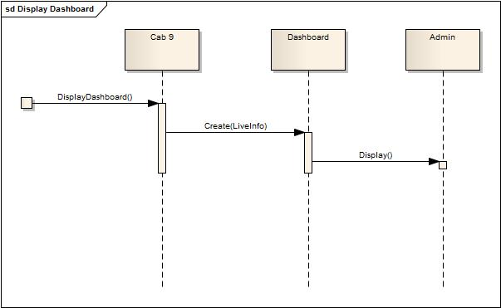

### 4.7.5 Operation Contract: Find Current Location

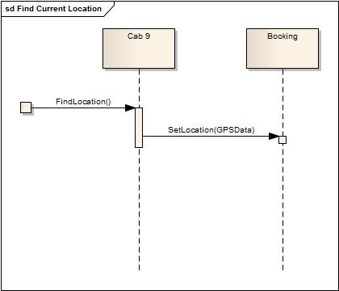

### 4.7.6 Operation Contract: Initialize

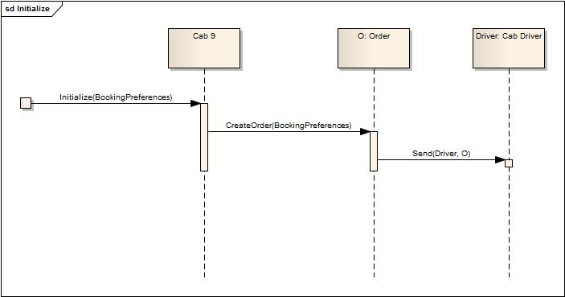

### 4.7.7 Operation Contract: Register User

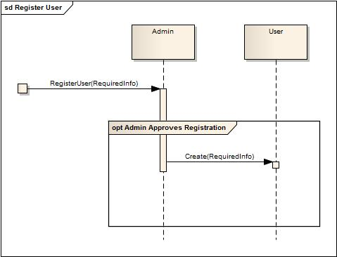

### 4.7.8 Operation Contract: Set Destination

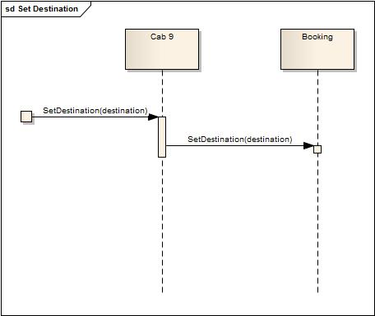

### 4.7.9 Operation Contract: Set Type of Cab

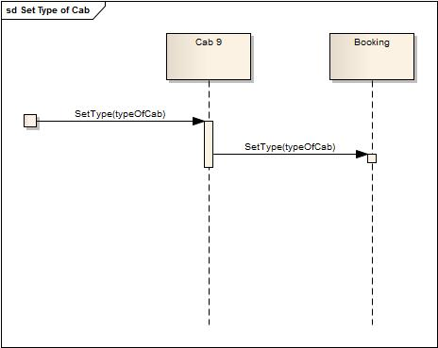

### 4.7.10 Operation Contract: Add Roadblock

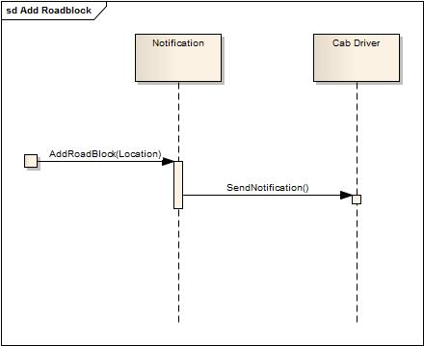

## 4.8 Initial Class Diagram

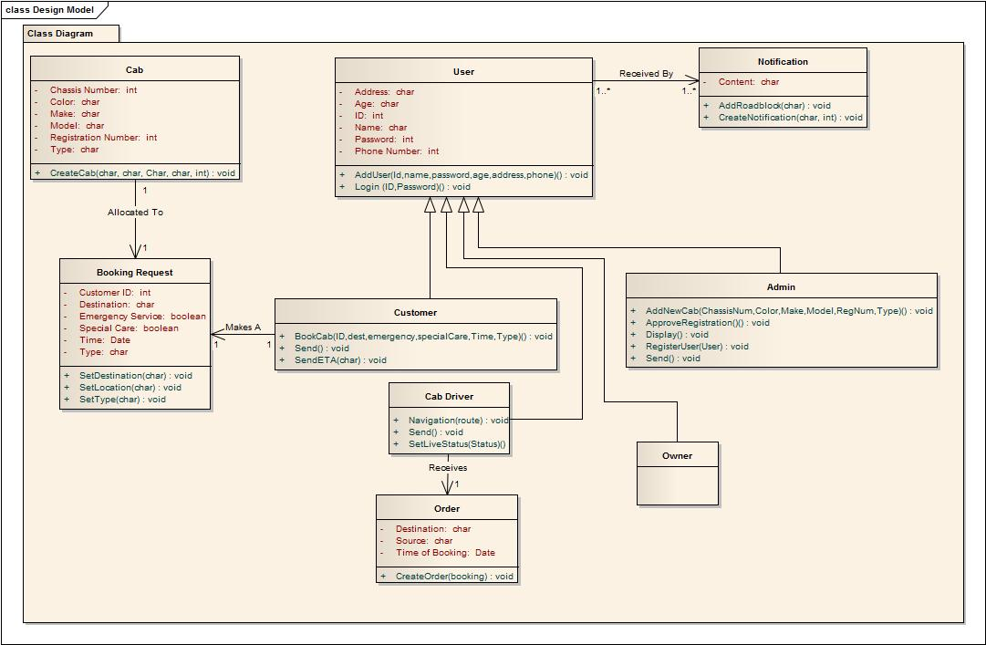

## 4.9 Package DiagramC:\Users\Waleed\Desktop\Package Diagram.jpg

## 4.10 Deployment Diagram

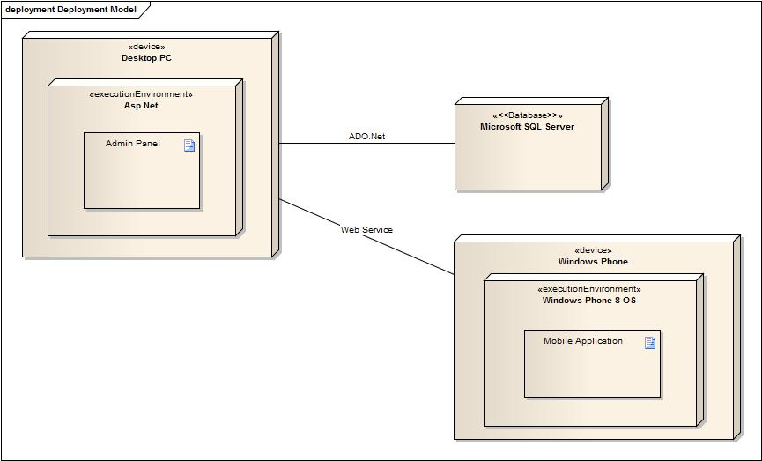

# Chapter 5. Database

## 5.1 Entity Relationship Model (ERD)

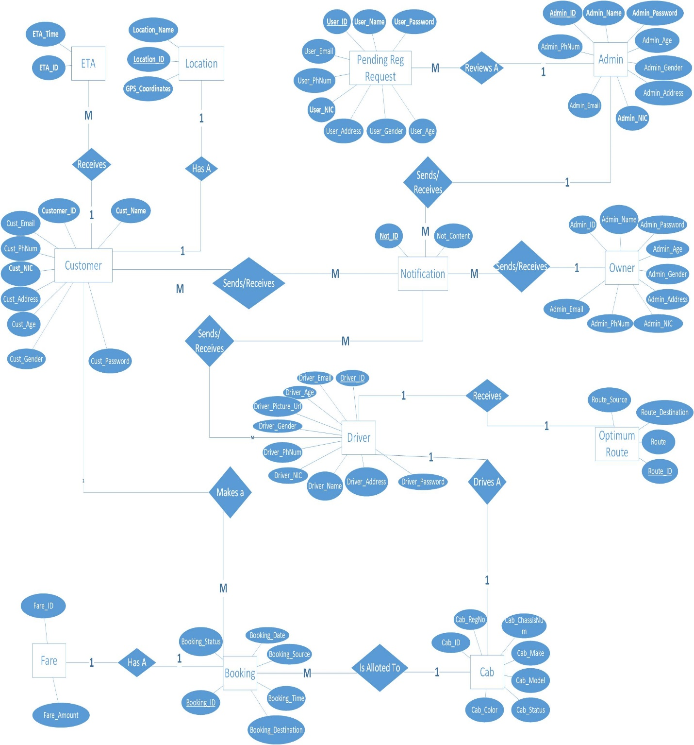

## 5.2 ER Model to Tables

|  |  |  |
| --- | --- | --- |
| S.No. | Entity | Attributes |
| 1 | Customer | 1. **ID (PK)** 2. Username 3. Password 4. Gender 5. Age 6. Address 7. PhoneNumber 8. Email 9. NIC |
| 2 | Cab | 1. **ID (PK)** 2. RegistrationNumber 3. ChassisNumber 4. Make 5. Model 6. Color 7. CabStatus 8. OwnerName |
| 3 | Booking | 1. **ID (PK)** 2. CustomerID 3. Destination 4. Source 5. Time 6. Date 7. BookingStatus |
| 4 | Location | 1. **ID (PK)** 2. GPSCoordinates 3. LocationName |
| 5 | Driver | 1. **ID (PK)** 2. Username 3. Password 4. Gender 5. Age 6. Address 7. PhoneNumber 8. Email 9. NIC |
| 6 | Fare | 1. **ID (PK)** 2. Amount |
| 7 | ETA | 1. **ID (PK)** 2. Time |
| 8 | Acknowledgement | 1. **ID (PK)** 2. Content |
| 9 | Order | 1. **ID (PK)** 2. Source 3. Destination 4. TimeOfBooking |
| 10 | OptimumRoute | 1. **ID (PK)** 2. Source 3. Destination 4. Route |
| 11 | PendingUserRegistrationRequest | 1. **ID (PK)** 2. Username 3. Password 4. Gender 5. Age 6. Address 7. PhoneNumber 8. Email 9. NIC |
| 12 | Admin | 1. **ID (PK)** 2. Username 3. Password 4. Gender 5. Age 6. Address 7. PhoneNumber 8. Email 9. NIC |
| 13 | Owner | 1. **ID (PK)** 2. Username 3. Password 4. Gender 5. Age 6. Address 7. PhoneNumber 8. Email 9. NIC |

## 5.3 Relational Model (Normalized)

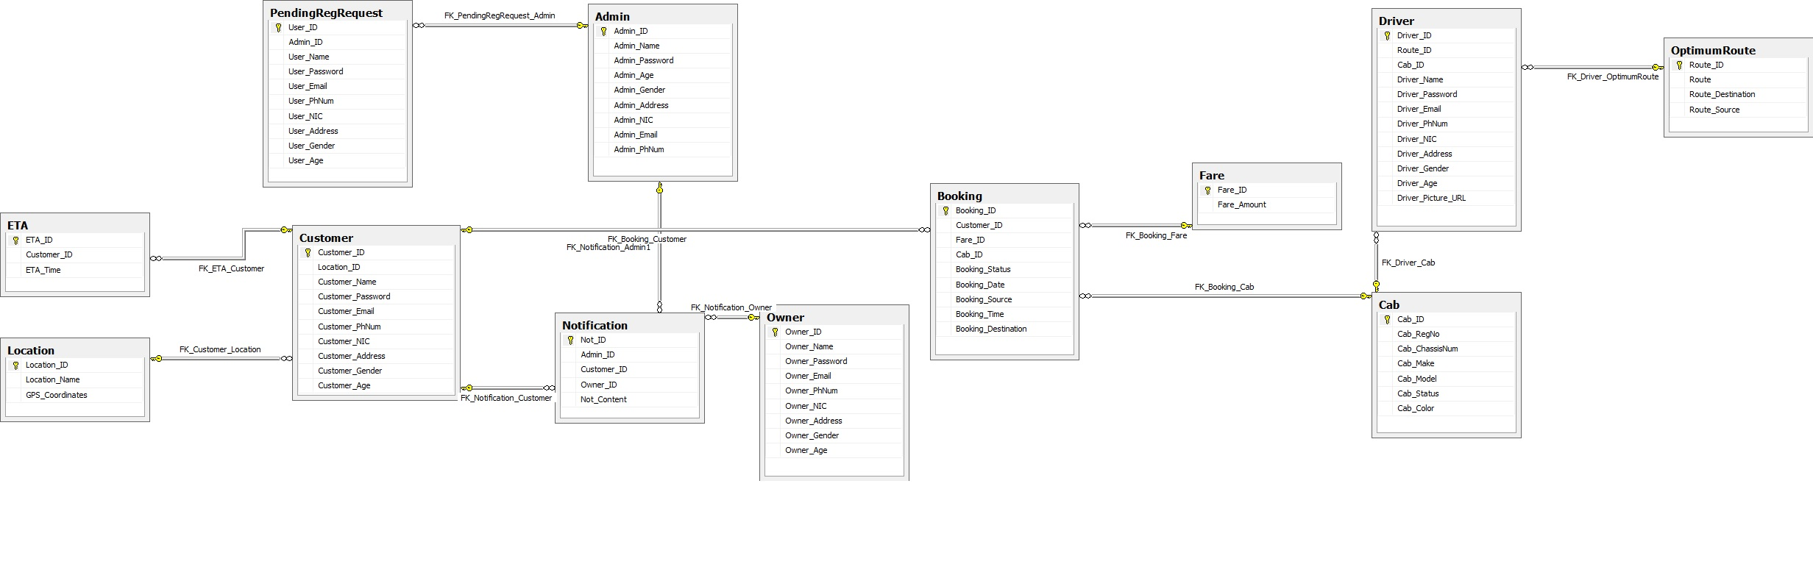

# Chapter 6: USER MANUAL

## GENERAL INFORMATION

### 1.1 System Overview

Cab9 has been designed and developed to facilitate the users in the process of acquiring a cab to travel to their desired location. Some of the salient features of Cab9 are as follows:

* Efficient cab allocation
* ETA disclosure
* Automatic Fare Calculation
* Optimum route calculation
* Allocation of replacement cab in case of any accident/unforeseen situation.
* Allocation acknowledgement by driver
* Booking cancellation facility
* Live cab monitoring and administration.

Users can access this system through their windows phone devices, through a dedicated application. Using the system through this application will facilitate the users and the administration in various ways. It will help the administration to acquire user’s location through GPS. It will also help the administration to acquire the location of all the cabs and monitor them in real time.

This system has been designed and developed as a final year project at the National University of Computer and Emerging Sciences, Islamabad by the group of Mr. Waleed bin Khalid, Mr. Muhammad Raza Chohan and Mr. Hadi bin Masood. Due to this, the system code is a proprietary property of the said institute.

1. System category:
2. *Major application:* performs clearly defined functions for which there is a readily identifiable need in the society of Pakistan.
3. Operational status:
4. Operational
5. General description

A system that will enable best utilization of cab company resources through localization bringing convenience and time saving for customer and efficiency to financial and resource management of Cab Company. Our system aims at relieving the customer from problems like finding the cab, excessive fares, delays due to traffic rush etc. It also allows the company management to monitor the financial statistics live and also the monitor business of the day. It also makes sure the most optimum use of resources creating value for customer and increasing profit margins for company.

1. System environment or special conditions

The system is completely MS Windows based, so in order to make use of it you need to have a Windows Phone 8 device with the dedicated application installed.

### 1.2 Authorized Use Permission

This system is protected by Intellectual Property Rights and any unauthorized use will render the offender admissible in the court of law to be penalized.

### 1.3 Points of Contact

#### 1.3.1 Information

In case of any queries and technical difficulties, feel free to drop an email or comment to any of the following personnel for extended support:

* Muhammad Raza Chohan [i110012@nu.edu.pk](mailto:i110012@nu.edu.pk)
* Waleed Bin Khalid [i110011@nu.edu.pk](mailto:i110011@nu.edu.pk)
* Hadi Bin Masood [i090965@nu.edu.pk](mailto:i090965@nu.edu.pk)

#### 1.3.2 Coordination

Coordination is required between the cab company and the system developers for the installation of the centralized administration portal on the server, so that the users can start using the application to place orders.

#### 1.4 Organization of the Manual

* System Summary
* Getting Started
* Using the System
* Querying

#### 1.5 Acronyms and Abbreviations

ETA – Estimated Time of Arrival

**2.0 SYSTEM SUMMARY**

## SYSTEM SUMMARY

### 2.1 System Configuration

As discussed, this system is built using the client/server architecture. So the clients (users & drivers) will be using the system through their Windows Phone 8 devices and the main administration panel is hosted on a Windows Server with Microsoft SQL Server as the database. The graphical representation of this architecture can be comprehended in the next section.

### 2.2 Data Flows

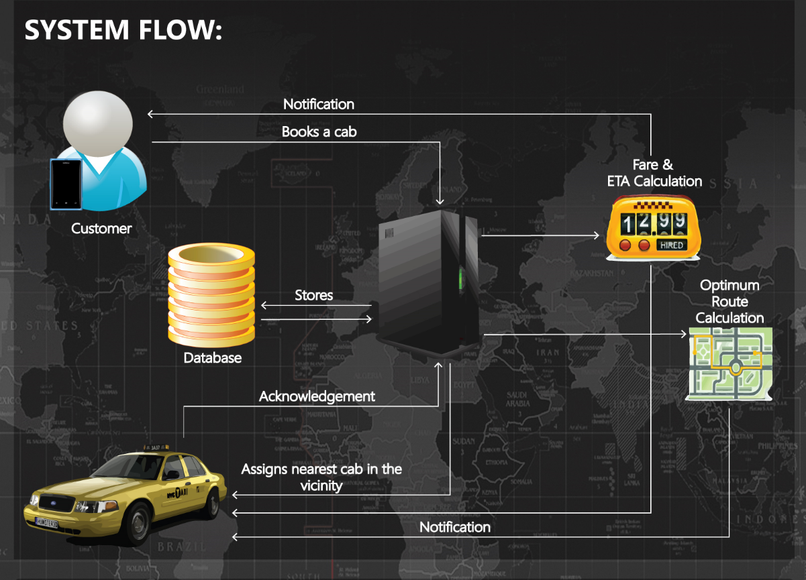

### 2.3 User Access Levels

According to the recorded stats users are classified as Regular or New on the basis of the frequency of their orders. Similarly users are blacklisted and their access to the system is revoked when they consecutively make prank orders for three times.

### 2.4 Contingencies and Alternate Modes of Operation

In case of any disaster or major downtime, the application load will be routed through the backup server and in case users are unable to connect to the Internet, they can book a cab through phone calls too.

**3.0 Using the System (Customer)**

## Using the System (Customer)

### 3.1 Logging On

When you access the application it prompts you to select Customer or Driver. Being a customer you can select the customer option, and then provide your respective credentials to log into the system.

### 3.2 System Menu

Through the system menu, you will be facilitated to book a cab, customize your credentials and cancel booking.

### 3.2.1 Booking a cab

When you select the option to book a cab, you will be asked for the following things:

* Type of cab
* Date & time of the booking
* Source of the booking: the origin of the booking is automatically set through acquiring GPS coordinates, you can change it by keeping your finger on the marker for three seconds and then placing the marker on your desired location.
* Destination of the booking: You have to keep pressing the screen on your desired location for consecutive three seconds to place a marker on the map.

### 3.3 Changing User ID and Password

A user cannot change their ID but they can change their password through the option provided in the menu. When you opt to change the password, your old password will be required and new password will be required twice to confirm.

### 3.4 Exit System

For any end user exiting the system is very easy. You have to close the application and the system will exit.

**4.0 USING THE SYSTEM (ONLINE)**

## USING the SYSTEM (Admin)

On the Administration side, the users/admins have an ASP.Net based administration portal. Their task is to add/remove cabs, drivers and moderate users.

### 4.1 Cab Allocation

Cab Allocation is done automatically (based on origin of booking). The admins will just monitor it through the live maps on the dashboard. When a user originates a booking request, the system automatically looks for the nearest available cab and allots it to the user. This can be seen on the Map on the dashboard.

### 4.2 Cab Registration

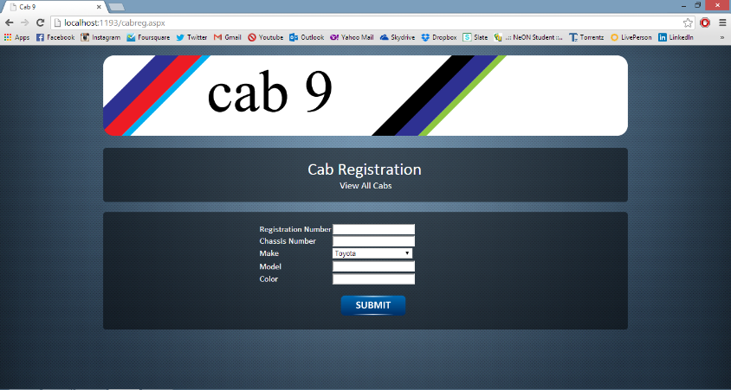When a new cab is available for the registration, an admin has to provide with the following information in order to register that cab into the system:

* Registration Number
* Chassis Number
* Make
* Model
* Color

Data conformity checks have been installed to make sure that the information is entered in the correct format.

### 4.3 Driver Registration

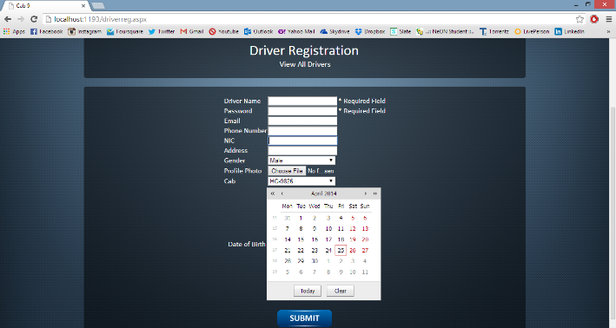When a new driver is available for registration, admins can register him in the system, through the dedicated form. The following information is required:

* Name
* Password
* Email
* NIC
* Photograph
* Address
* Gender
* Age
* Allotted Cab (This dropdown menu is populated by the already available cabs)

**5.0 USING THE SYSTEM (Driver)**

## USING the SYSTEM (DRIVER)

Every driver registered with Cab9 will be provided with a Windows Phone 8 device to facilitate in their location acquisition and respective notifications. Drivers on duty are always required to have their phones turned on and logged in to the application, for making sure that the application does the tasks automatically.

### 5.1 Location Acquisition

It is a business rule for all the drivers to have their Windows Phone with them all the time. When they are on duty it is compulsory for them to be connected to the Internet, so that their location can be acquired through the phone’s GPS and allotted to the next Booking.

System Screenshots

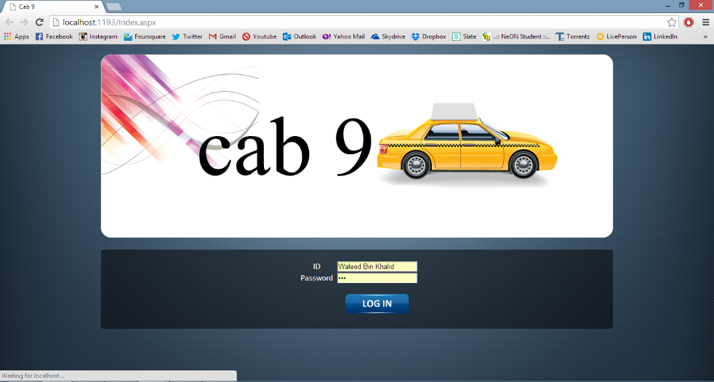Login Page

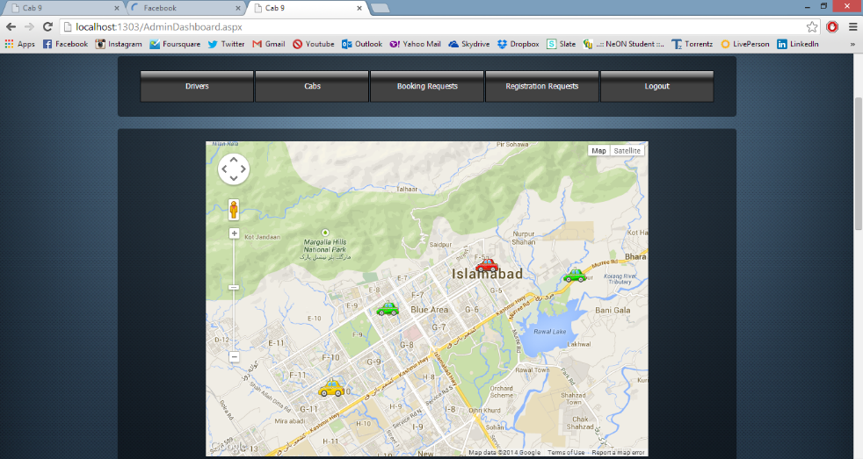Admin Dashboard

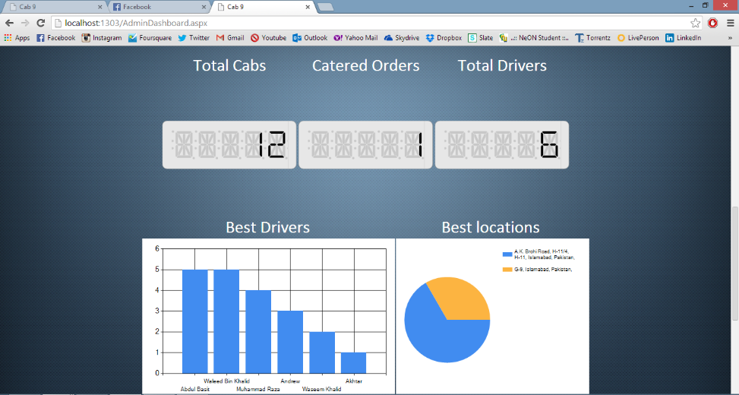Stats Panel

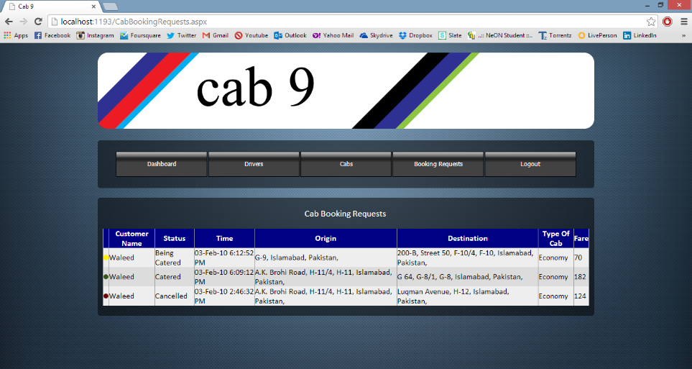 Booking Requests

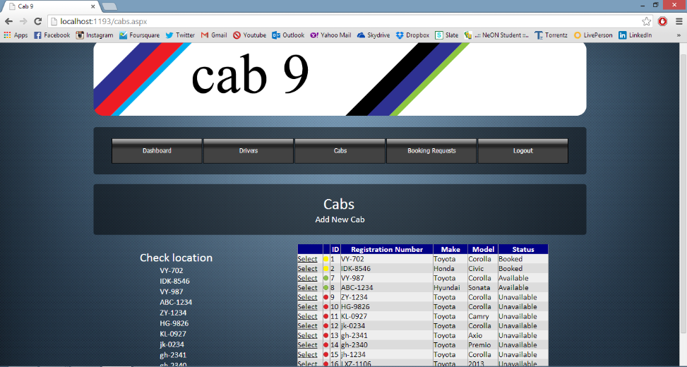 Cabs Dashboard

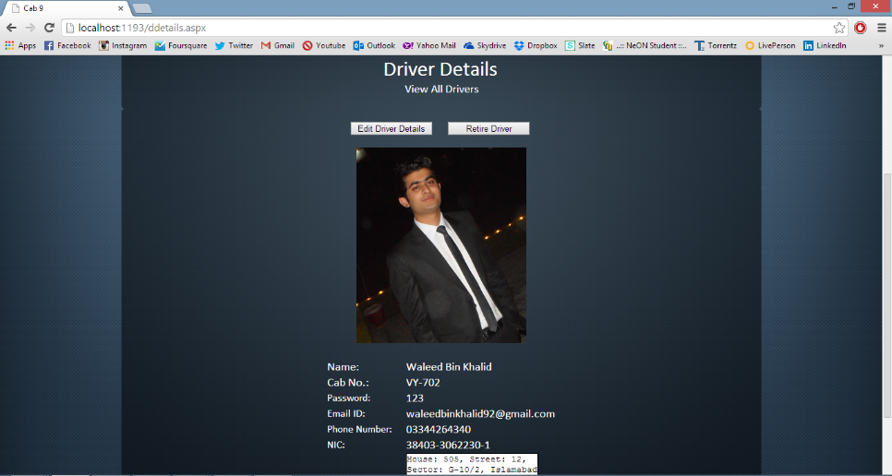 Driver Details

# Chapter 7. References

[1] [www.play.google.com/store/apps/details?id=com.taxipixi.taxiexchange&hl=en](http://www.play.google.com/store/apps/details?id=com.taxipixi.taxiexchange&hl=en)

[2] www.appdunia.com/2013/05/taxipixi-multi-operator-taxicab-booking-mobile-application/

[3]  [www.play.google.com/store/apps/details?id=uk.co.dialacab.app](https://play.google.com/store/apps/details?id=uk.co.dialacab.app)

[4]  [www.play.google.com/store/apps/details?id=biz.gotaxi&hl=en](https://play.google.com/store/apps/details?id=biz.gotaxi&hl=en)

[5]  [www.play.google.com/store/apps/details?id=br.com.easytaxi](https://play.google.com/store/apps/details?id=br.com.easytaxi)

[6]  [www.play.google.com/store/apps/details?id=au.com.mtaxi](https://play.google.com/store/apps/details?id=au.com.mtaxi)

[7]  [www.play.google.com/store/apps/details?id=com.infindo.expresstaxi&feature=search_result#?t=W251bGwsMSwyLDEsImNvbS5pbmZpbmRvLmV4cHJlc3N0YXhpIl0](https://play.google.com/store/apps/details?id=com.infindo.expresstaxi&feature=search_result#?t=W251bGwsMSwyLDEsImNvbS5pbmZpbmRvLmV4cHJlc3N0YXhpIl0)